**COMSATS University Islamabad (CUI)**

**Project Report**

**for**

**SUPPLY CHAIN MANAGEMENT (Optimized AI Searches)**

(The main purpose is to achieve the optimized way of searching paths and finding nodes)

Version 1.0

***By***

**Hasaan Ahmed SP22-BSE-017**

**Mona Khalil SP22-BSE-028**

***Submitted To:***

**Sir Waqas Ali**

***Bachelor of Science in Computer Science (2022-2025)***

Contents

Executive Summary: 2

SUPPLY CHAIN MANAGEMENT: 3

1. Introduction 3

2. Problem Statement 3

3. Problem Solution/Objectives of the Proposed System 3

4. CODE: 4

4.1 CSV FILE: 4

4.2 OUTPUTS: 8

5. Working of Algorithms: 11

6. Tools and Technologies 12

# Executive Summary:

Our project aims to revolutionize supply chain management through an AI-driven system developed using Python. By employing advanced algorithms like Uniform Cost Search, Depth-First Search, Breadth-First Search, and A*, our solution optimizes decision-making processes, enhances inventory management, and ensures real-time stock updates. With a focus on reducing procurement lead times, improving operational efficiency, and boosting user experience, our software promises to elevate organizational productivity and adaptability in the face of market dynamics. Through comprehensive tools and technologies such as VS Code and Python 3.12.3, we provide a user-friendly solution tailored to meet the evolving needs of modern businesses.

# SUPPLY CHAIN MANAGEMENT:

# Introduction

In today's highly competitive commercial landscape, effective supply chain management is crucial for organizational success. This project aims to develop an AI-powered supply chain management system using Python. By leveraging AI algorithms such as Uniform Cost Search (UCS), Depth-First Search (DFS), Breadth-First Search (BFS), and A*, the system will enable real-time analysis and strategic planning. These algorithms will intelligently navigate the supply chain network to optimize decision-making processes, identify cost-effective routes, improve overall performance, and optimize inventory management. Our AI-driven solution will empower businesses to adapt swiftly to market fluctuations

# Problem Statement

The current supply chain management system lacks real-time updates on stock availability, leading to dissatisfaction and inefficiency among employees. As a result, the procurement process is delayed and inconsistent, with staff spending an average of thirty minutes daily traversing the supply chain. This impacts job satisfaction and productivity. To address these issues, we aim to develop software that provides real-time stock updates, streamlines procurement, and reduces the time required to acquire supplies. Our goal is to enhance the working environment, increase operational efficiency, improve supply chain management, and save time and effort.

# Problem Solution/Objectives of the Proposed System

Our software solution aims to enhance procurement procedures, implement real-time inventory tracking, and improve user experience to optimize supply chain management. We seek to reduce lead times for ordering goods, enhance operational effectiveness by providing precise stock level information, and prioritize flexibility, scalability, and usability to accommodate the company's changing needs. By leveraging data security protocols and collaboration tools, we aim to promote creativity, teamwork, and well-informed decision-making. Ultimately, our objective is to develop a comprehensive solution that boosts productivity, reduces expenses, and generates long-term value for the company.

# CODE:

## CSV FILE:

supply_chain_data.csv

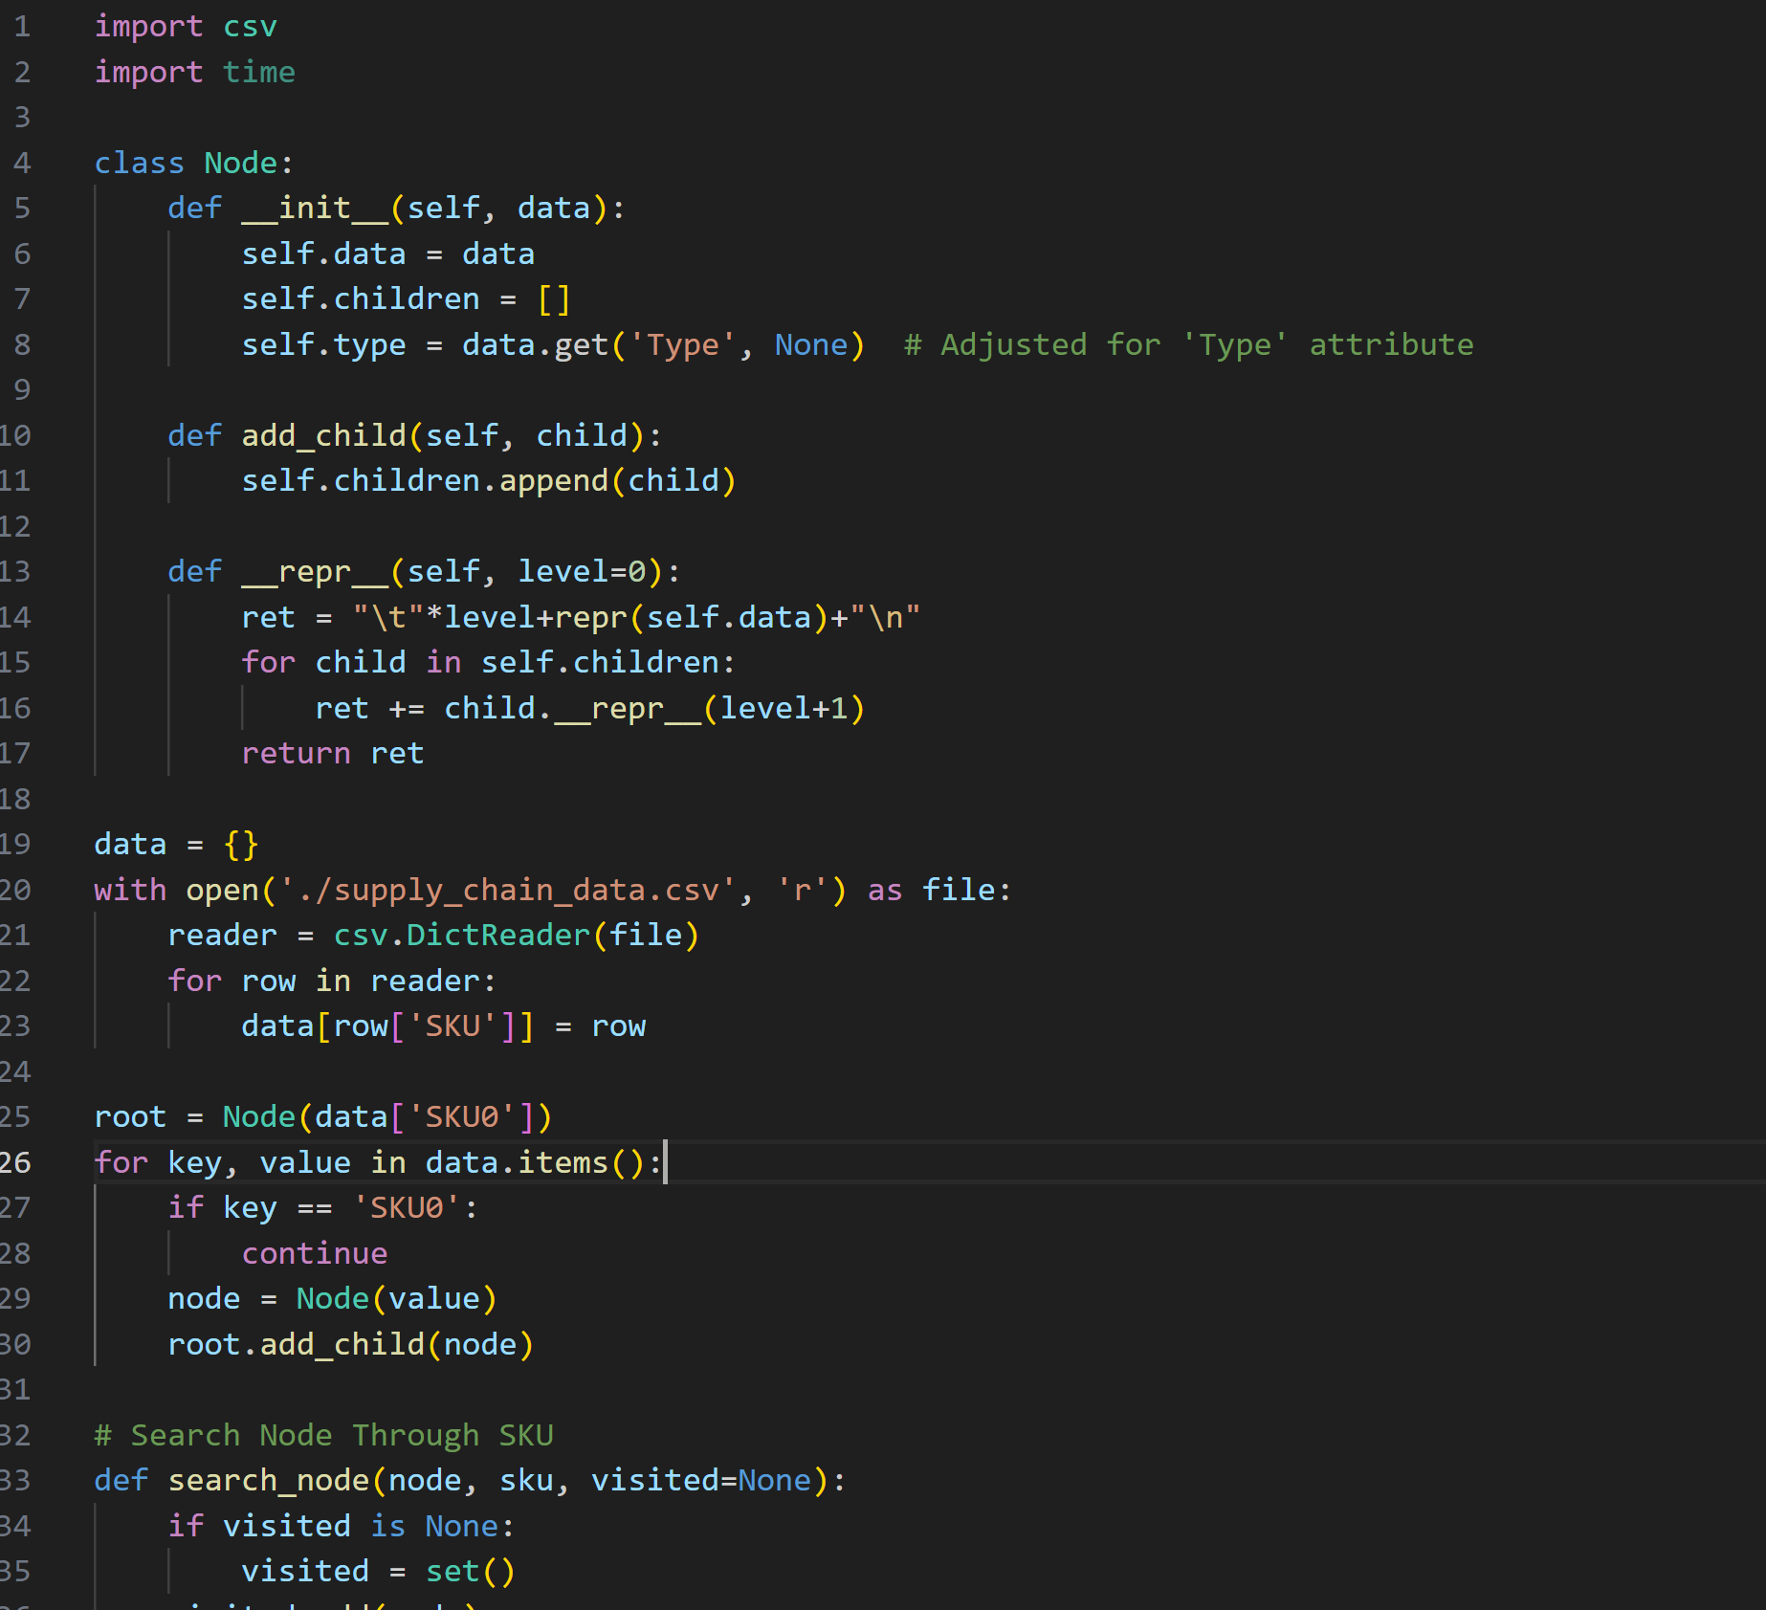

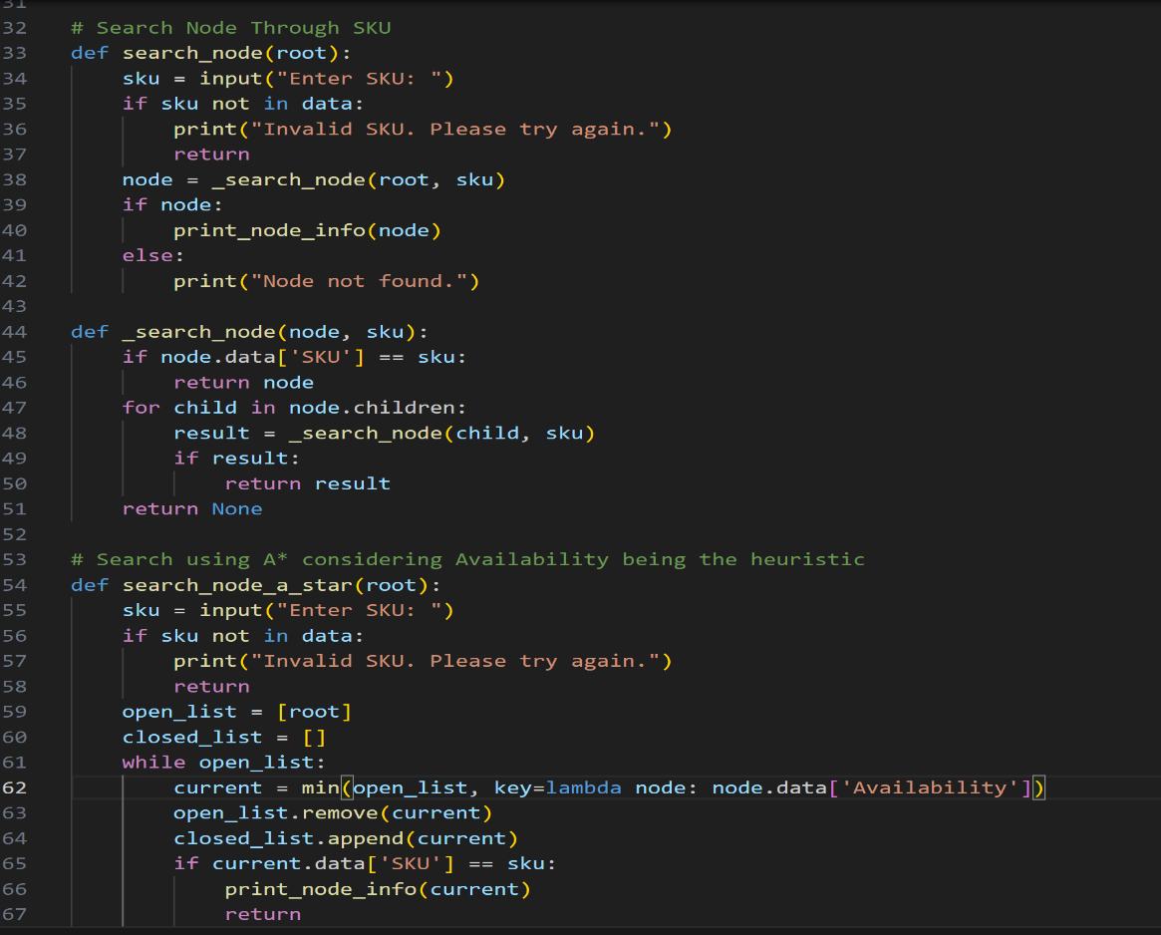

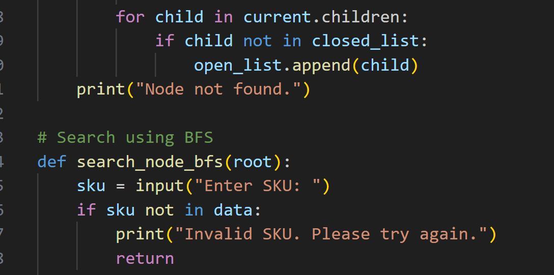

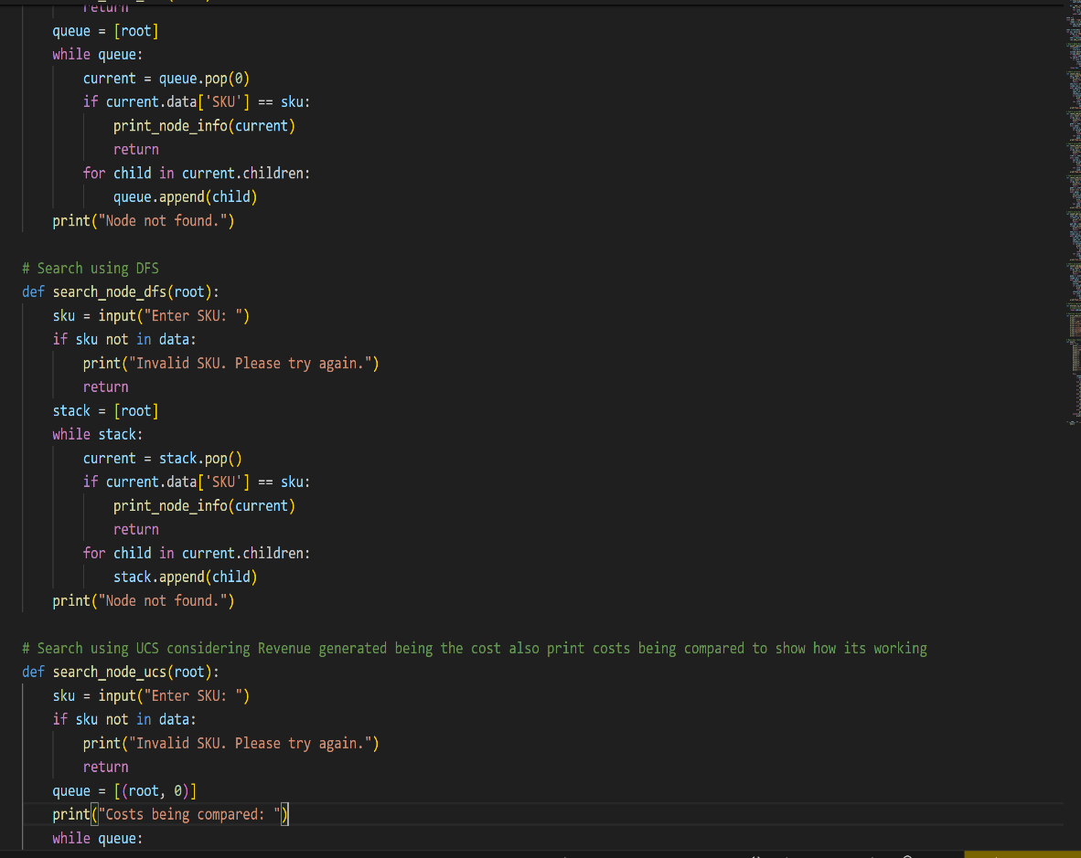

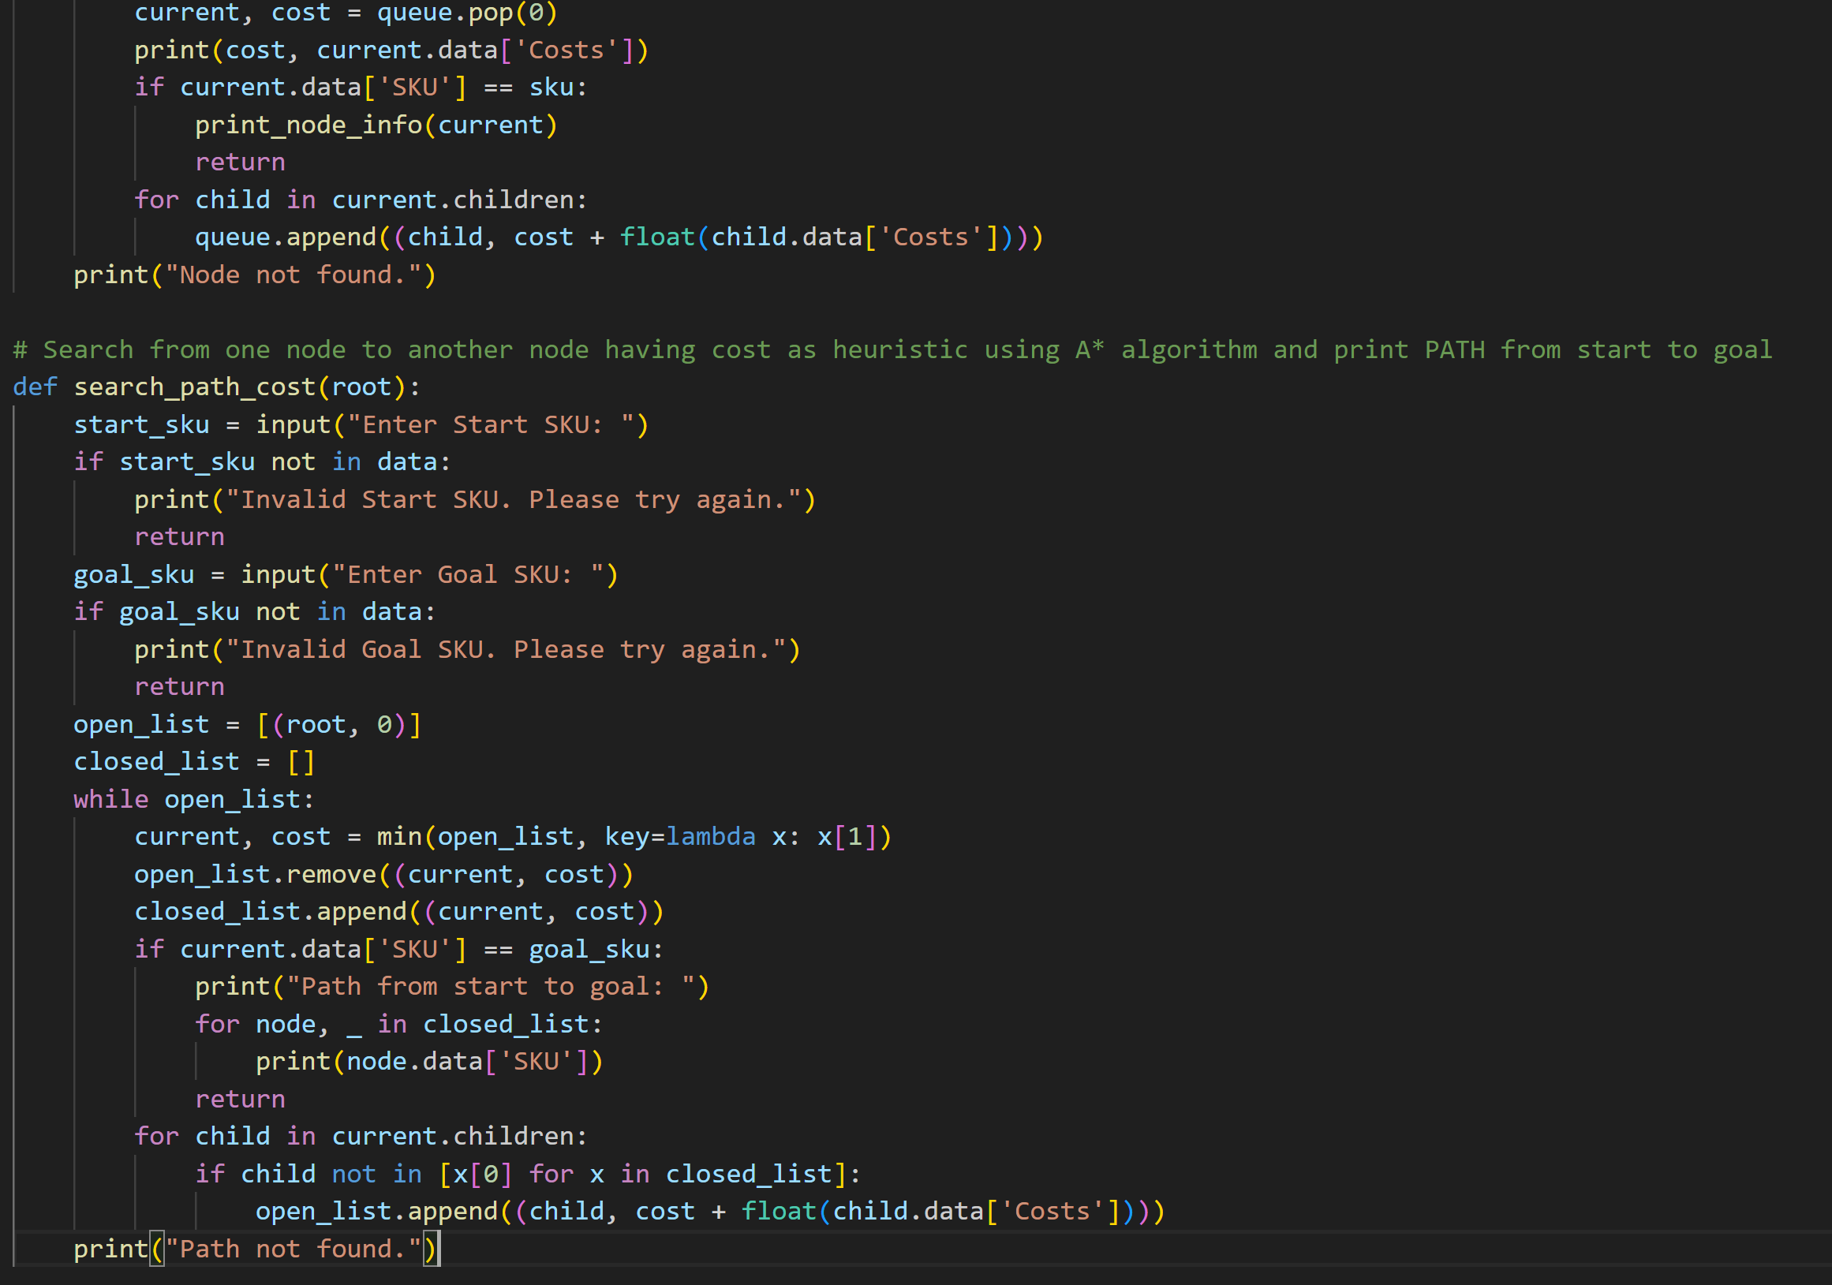

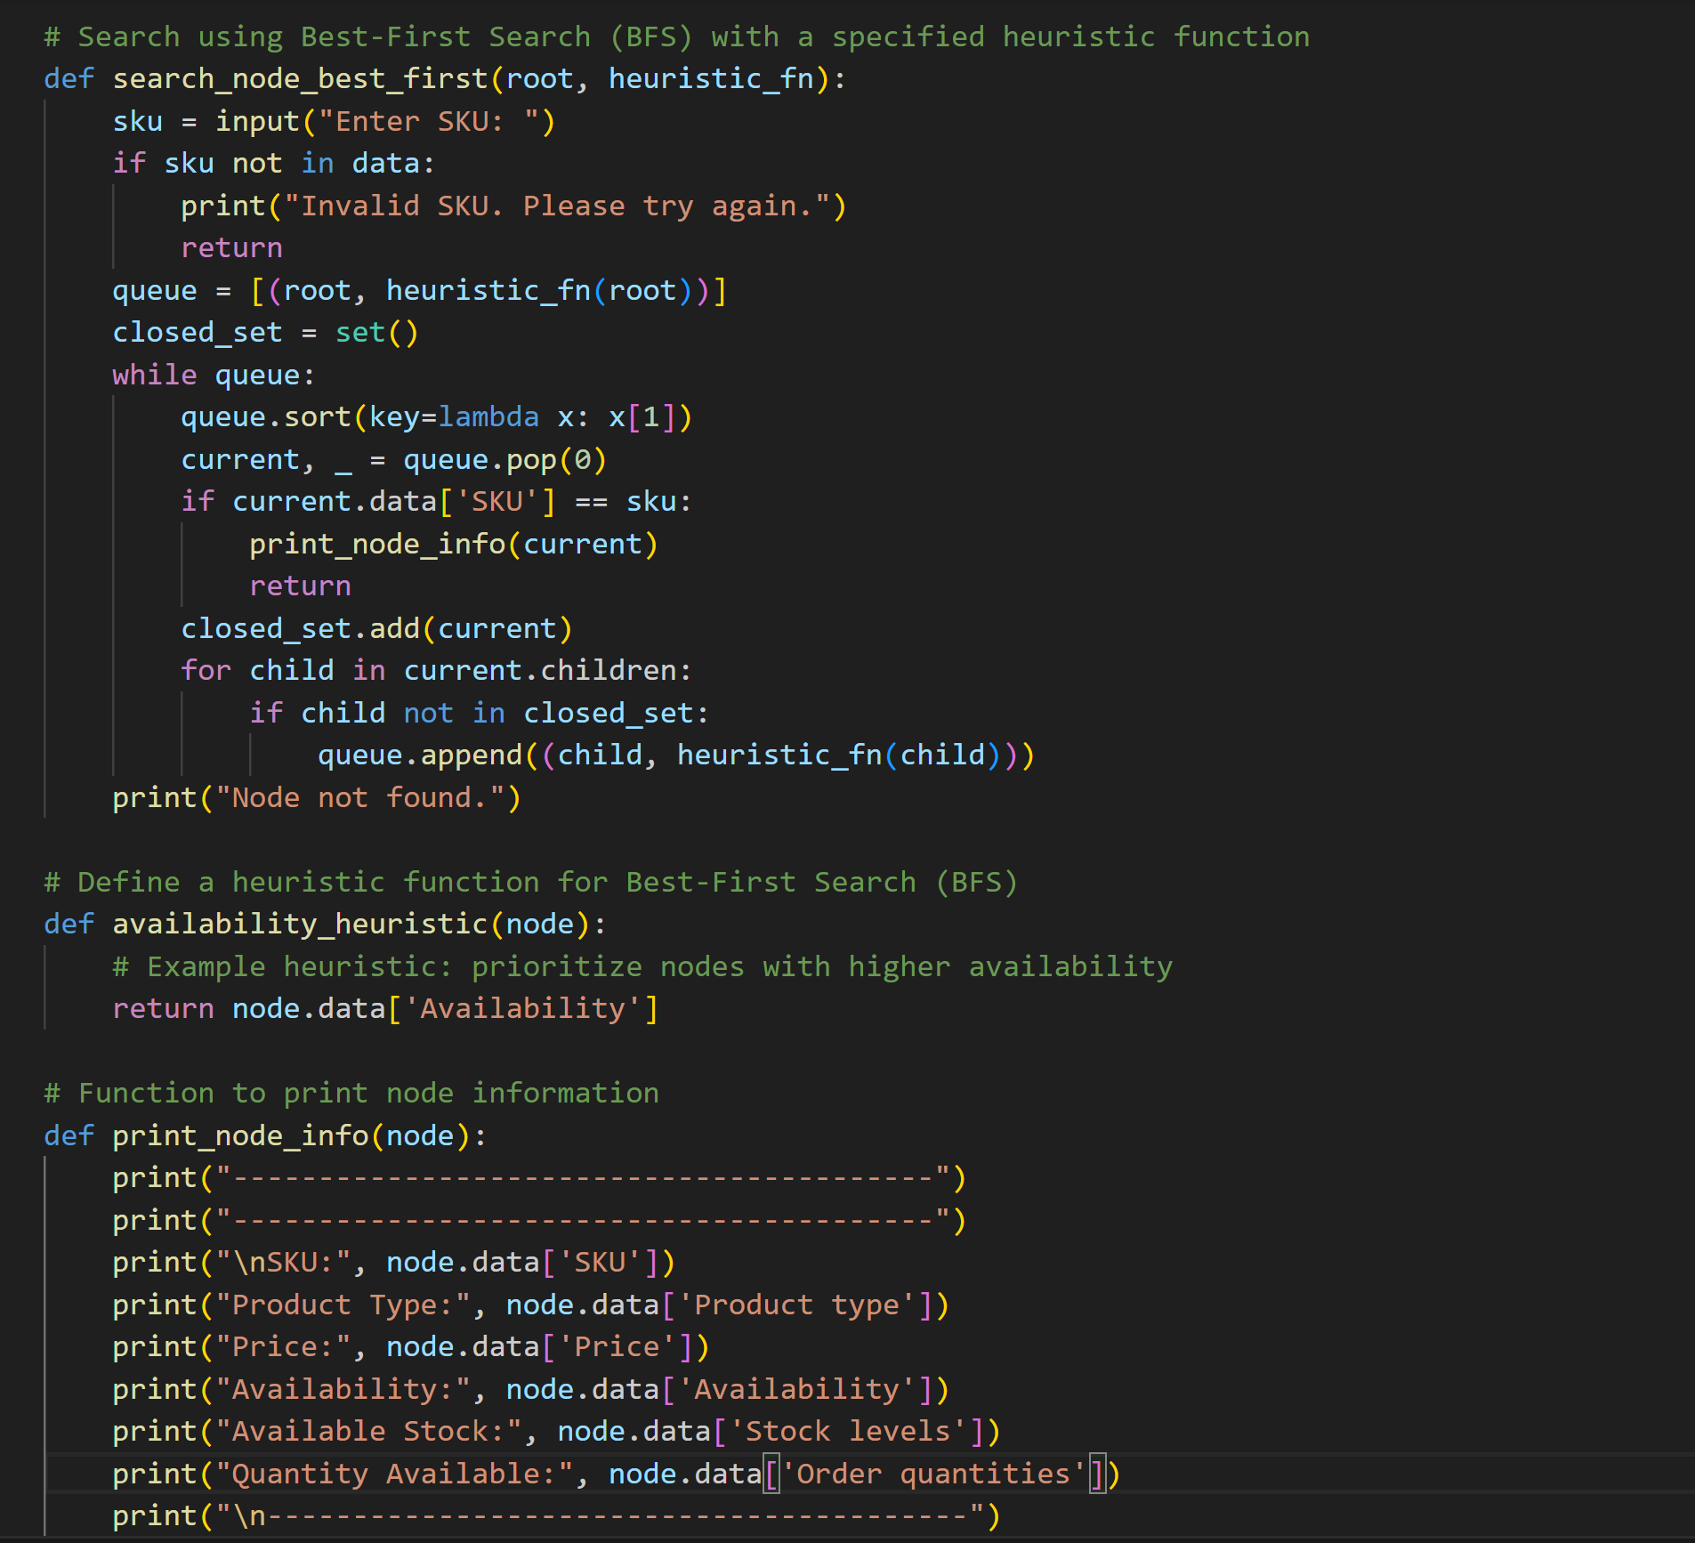

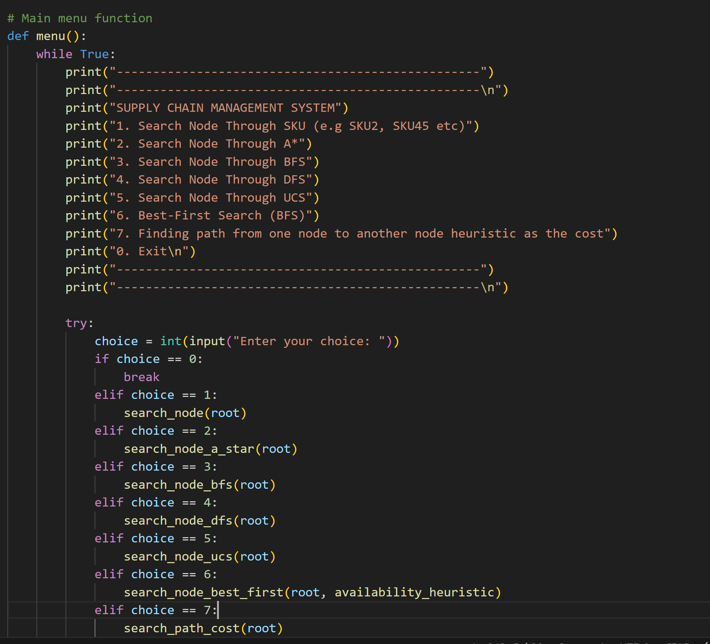

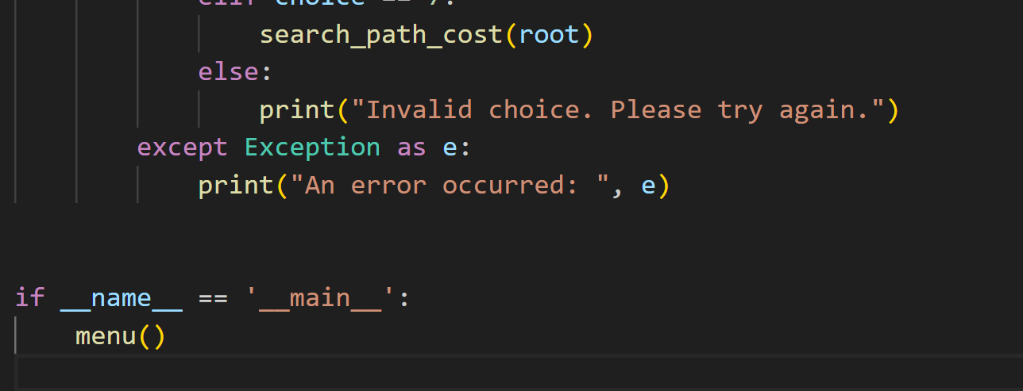

## OUTPUTS:

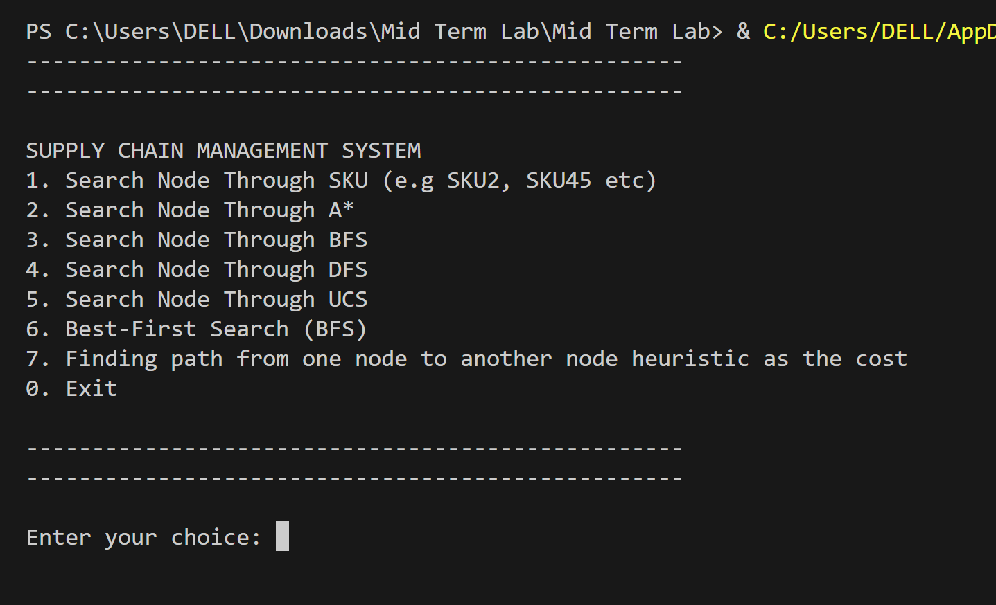

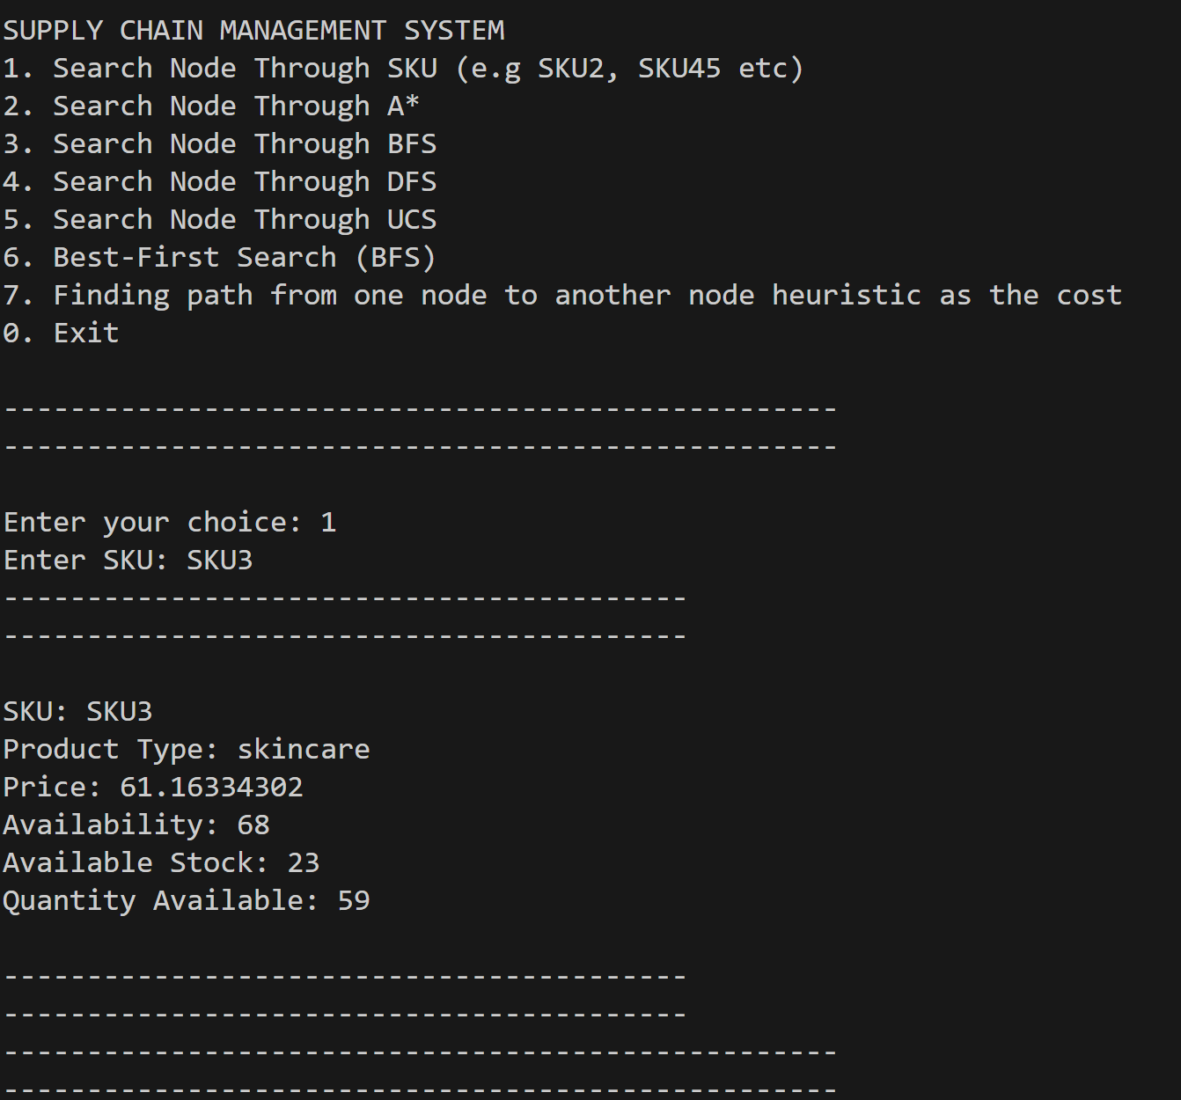

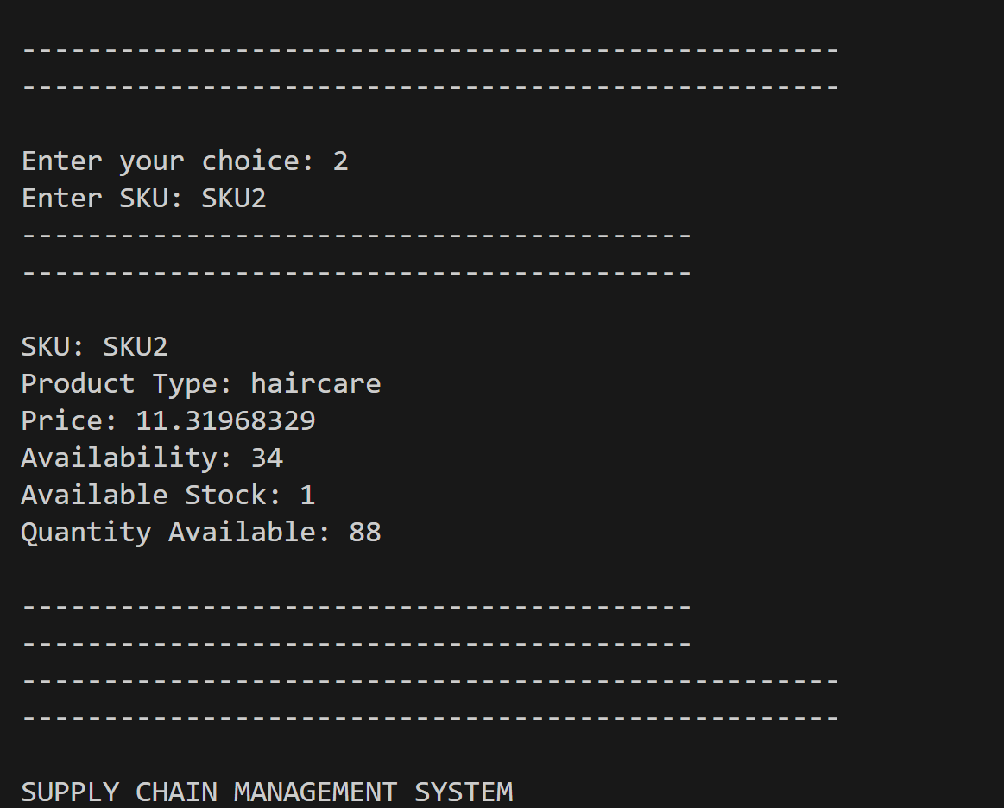

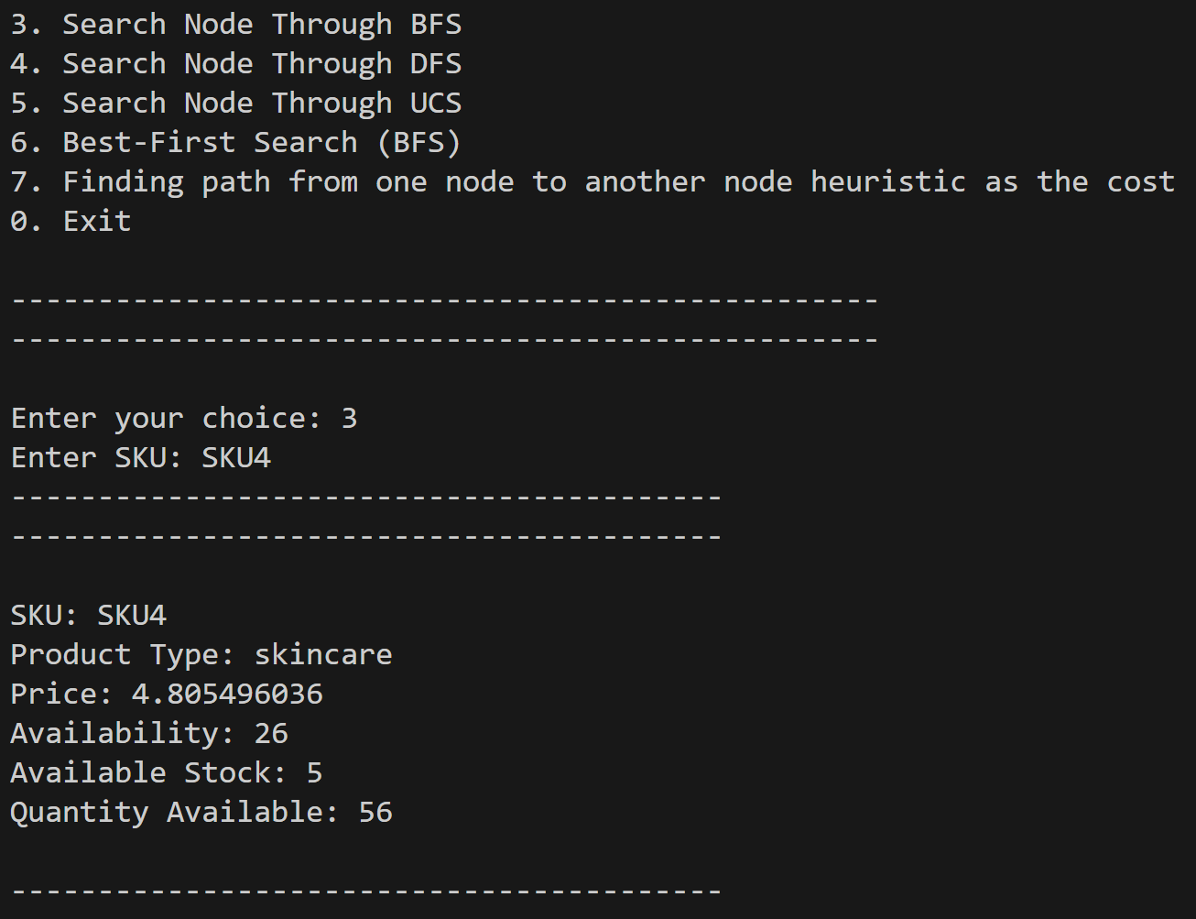

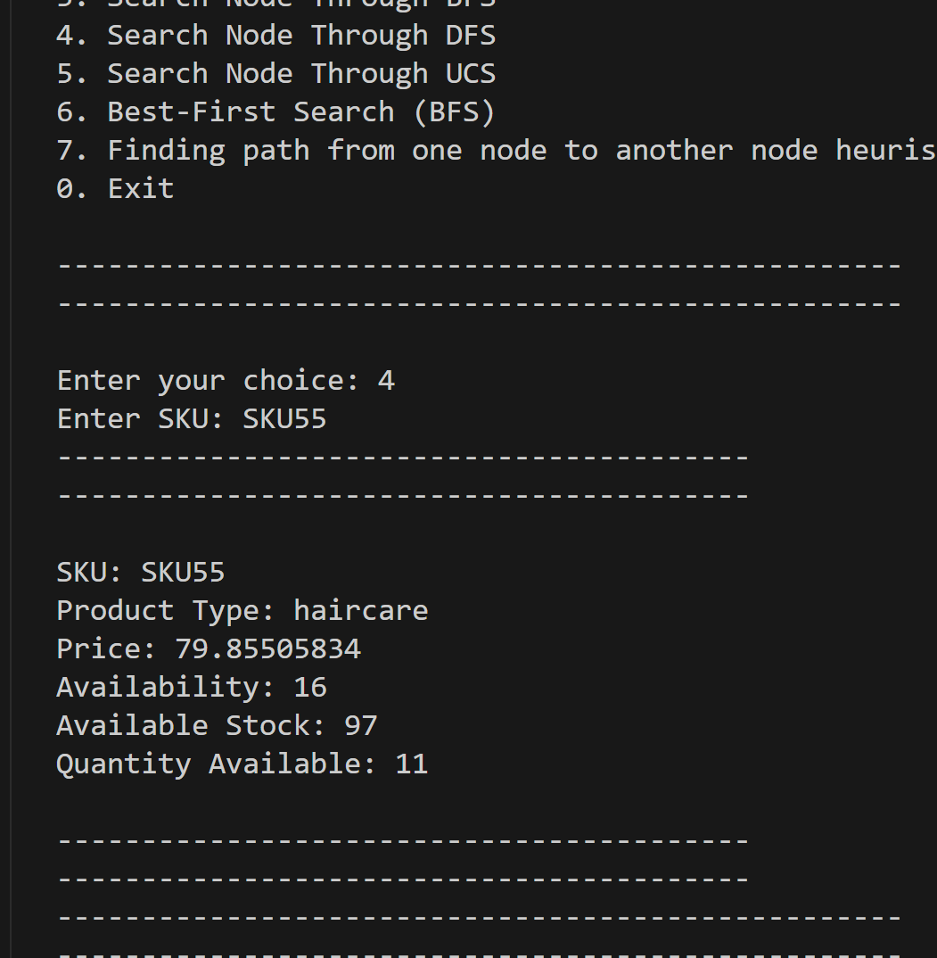

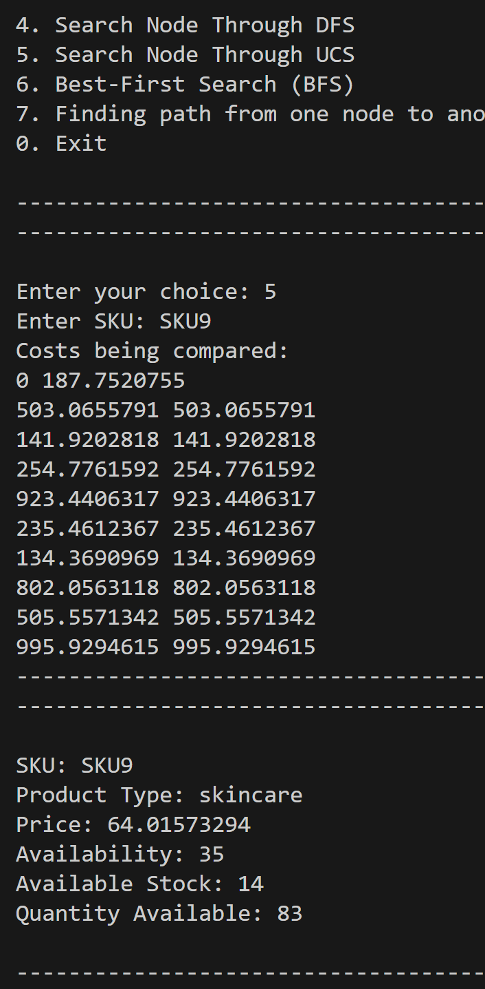

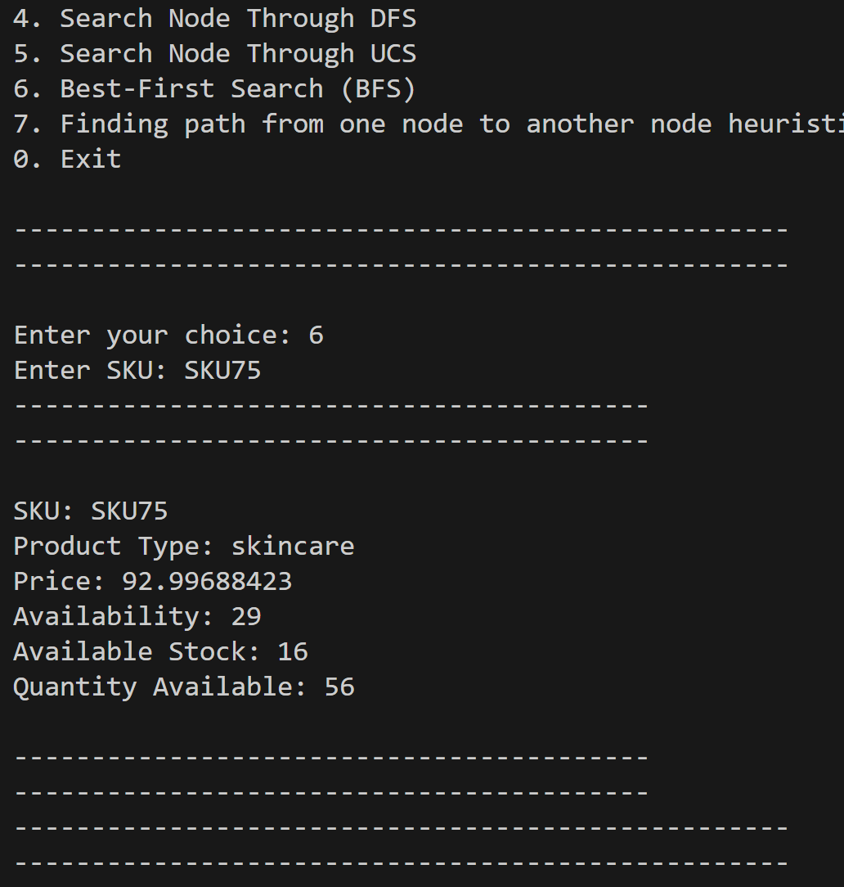

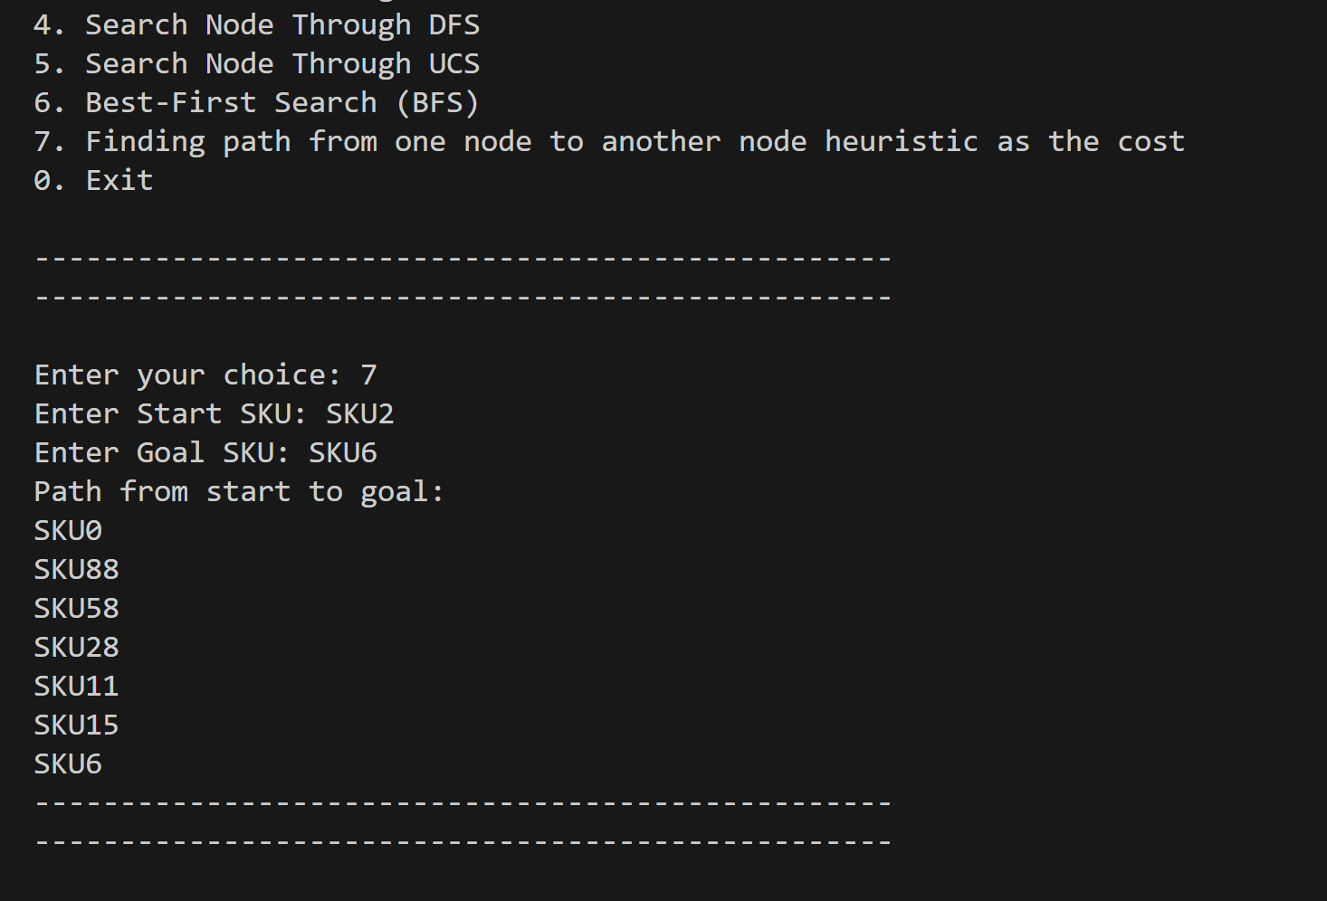

# Working of Algorithms:

1. **A Search Algorithm*:**
   * User inputs SKU to search.
   * Checks if SKU exists, if not, informs the user.
   * Initializes open and closed lists.
   * Selects nodes based on minimum availability.
   * If goal found, prints node information and exits.
   * If not, expands nodes and continues.
   * Informs if SKU not found.
2. **Breadth-First Search (BFS)**:
   * User inputs SKU to search.
   * Checks if SKU exists, if not, informs the user.
   * Initializes queue with root node.
   * Explores nodes level by level.
   * If goal found, prints node information and exits.
   * If not, continues exploring.
   * Informs if SKU not found.
3. **Depth-First Search (DFS)**:
   * User inputs SKU to search.
   * Checks if SKU exists, if not, informs the user.
   * Initializes stack with root node.
   * Explores nodes deeply before siblings.
   * If goal found, prints node information and exits.
   * If not, continues exploring.
   * Informs if SKU not found.
4. **Uniform Cost Search (UCS)**:
   * User inputs SKU to search.
   * Checks if SKU exists, if not, informs the user.
   * Initializes priority queue with root node and cost.
   * Explores nodes with lowest cost.
   * If goal found, prints node information and exits.
   * If not, continues exploring.
   * Informs if SKU not found.
5. **Finding Path with Heuristic Cost**:
   * User inputs start and goal SKUs.
   * Checks if both exist, if not, informs the user.
   * Initializes open and closed lists.
   * Explores nodes based on lowest combined cost and heuristic.
   * If goal found, prints path and exits.
   * If not, continues exploring.
   * Informs if path not found.

# Tools and Technologies

Table 1: Tools and Technologies for Proposed Project

|  |  |  |  |
| --- | --- | --- | --- |
| **Tools**  **And**  **Technologies** | **Tools** | **Version** | **Rationale** |
| VS CODE | 1.88 | IDE |
|  |  |  |
| **Technology** | **Version** | **Rationale** |
| Python | 3.12.3 | AI Searches Algorithms |
| **Dataset** | **Name** | **Rationale** | |
| Supply Chain CSV | Supply Chain Example dataset | |

# 